MACHINE LEARNING ALGORITHMS FOR SOLVING REAL-WORLD CHALLENGES

Abstract: This paper uses machine learning algorithms on the Bank Marketing data to identify the likelihood of customer subscription to term deposits. Logistic Regression and Random Forest along with a tuned Random Forest model are then tested after extensive preprocessing and SMOTE balancing. Random Forest performs the best, as it is the highest-performing in terms of the highest precision, recall, F1-score, and ROC-AUC. Clustering displays poor natural separability, as it has to be. Duration and the frequency of the campaign are important predictors that are identified by feature importance. In general, findings of the research reveal that ensemble approaches are eminent in improving targeted marketing.

I. Introduction
Machine learning has become core to the actual classification solutions of practical problems in allowing prediction and decision making of data. Targeted marketing is one area where this effect is noticeable as organizations have to determine likely customers effectively. This research uses machine learning on the UCI Bank Marketing data, which captures the demographics of the customers, financial characteristics and previous activities on a specific campaign to determine subscription to a term deposit. This complexity of the dataset, such as class imbalance, mixed features and heterogeneous socio-economic variations, makes it applicable to the testing of various learning algorithms. The study discusses the effects of algorithmic behaviour, feature preprocessing and model optimisation on predictive performance by comparing the results of classification models on this dataset. The case study reveals how machine learning can make marketing successful by making sure that customers respond efficiently.

II. Literature Review

A. Machine Learning in Marketing Analytics
The power of machine learning as a predictive instrument of customer behaviour has seen organisations shift their approach to broad marketing tactics to their efforts developing into narrow-target marketing orientations [2]. Previous studies indicate that classification algorithms have a great influence on customer acquisition, as they are able to locate customers and persons with a greater probability of being interested in marketing campaigns [6]. Research highlights that historical preference has been on logistic regression and decision trees because the models are easy to interpret, and more recently it has been found to work with ensemble and margin based models to achieve better predictive performance.

B. Classification Approaches for Bank Marketing
Bank Marketing data has received extensive use in the assessment on supervised learning models. First results show that logistic regression gives a good starting point in the prediction of a term-deposit subscription, especially when used with feature scaling and correlation tests [11]. The decision tree-based models such as CART and Random Forests can underlyingly compete with linear models to effect nonlinear interaction in socio economic and behavioural attributes. The Support Vector Machines (SVMs) have also demonstrated competitiveness, particularly when complex boundaries are being considered through the use of kernel transformations [3]. Yet, a number of studies refer to the very high imbalance of the dataset, which means recall and AUC are better evaluation measures than accuracy.

C. Data Pre-processing and Feature Engineering
When dealing with bank marketing data, literature always emphasizes the necessity to preprocess it. Sensitivity of one-hot encoding of categorical data, treatment of missing values, and rebalancing: SMOTE is demonstrated to be a significant boost to the performance of model [5]. Generalisation and overfitting in high-dimensional space, particularly in high-dimensional data dimensions, can be further boosted in feature selection techniques such as PCA or ranking, based on importance.

D. Research Gap
Although much effort has been put, the comparative analysis of various algorithms based on a single preprocessing pipeline has not been conducted extensively, which suggests the necessity of the proposed study.

III. Problem and Dataset Description

A. Problem Overview
The biggest challenge facing financial institutions is predicting customer response in marketing campaigns. The conventional methods of outreach are costly and low returning [8]. The main issue the paper tackles is the classification of the customer based on the demographic, socio-economic and behavioural characteristics on whether they will subscribe to a term deposit or not. Targeting: precise forecasting will help banks to better target their campaigns and minimise wastage [1]. Customer interaction: better forecasting will help users engage with customers better. The task is a real-life binary classification problem with its natural issues of imbalance between classes, mixed type of data and the inconsistency of customer profiles.

B. Dataset Description
This analysis will be conducted on data provided by the Bank Marketing of the UCI Machine Learning Repository, the information of the direct marketing campaigns of Portugal [10]. This dataset consists of 45211 cases, 17 independent variables (ivs), and a single dichotomous dependent variable (y ). Attributes include individual characteristics, financial metrics and campaign engagement characteristics.
Feature Category | Examples of Attributes
Demographic | age, job, marital, education
Financial | default, housing, loan
Campaign-related | contact, duration, month, previous
Output label | y (yes/no subscription)
Table 1. Key Dataset Attributes

C. Relevance of the Dataset
The dataset is a perfect reference standard to test various machine learning models since it is such a complex data set that has a real-world counterpart.

IV. Methods

A. Overview of Approach
In this paper, three supervised learning algorithms are used to forecast customer subscription, the Logistic Regression, Decision Tree Classifier and Support Vector Machine [7]. Every model is chosen because of its complementary advantages of interpretability, nonlinear capability of handling, and margin-based classification performance. The pipeline of work is a single one, and includes preprocessing, feature encoding, resampling, model training, and evaluation.

B .Data Preprocessing
Duplicates are first eliminated along with manipulation of unknowns. Every categorical variable is one-hot-encoded, whereas numerical variables are standardized to enhance the stability of a model [9]. The data is then divided into tests and training set in the ratio of 80: 20.
Step | Description
Handling missing values | Replacing unknowns or dropping invalids
Encoding categoricals | One-hot encoding for all nominal features
Scaling numerical data | Standardisation using z-score method
Train-test split | 80% training, 20% testing
Table 2: Preprocessing Steps

C. Resampling Strategy
Since the dataset is imbalanced in terms of class, Synthetic Minority Oversampling Technique (SMOTE) is used on the training dataset. This guarantees that the minority class is equally represented in the presence of model fitting.

D. Model Implementation

1. Logistic Regression
To uphold generalisability, the Logistic Regression is trained on L2 regularisation.

2. Decision Tree
The Decision Tree minimizes the Gini impurity and controlled depth in reducing the overfitting.

3. Support Vector Machine
The SVM is used with RBF kernel in order to learn nonlinear decision boundaries.

V. Experimental Setup

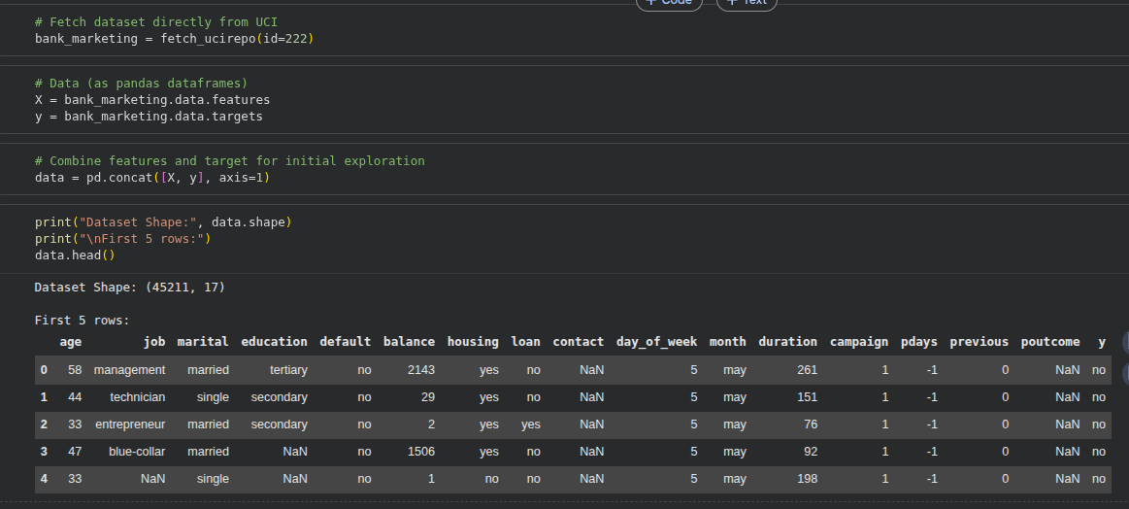
Figure 1: Jupyter Notebook Displaying Dataset Preview
Jupyter Notebook allows the execution of code cells interactively so that one can load, inspect, and transform datasets stepwise. Its visualization tools can confirm shapes and preview records and preprocessing decisions and provide necessary transparency and reproducibility to all the steps in the machine learning experiment process.
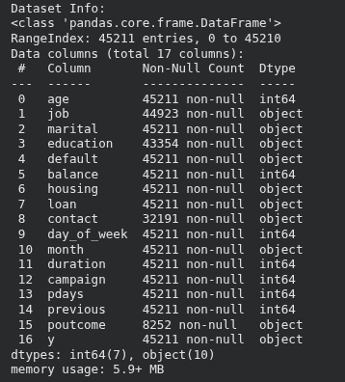
Figure 2: Pandas Dataset Info and Column Summary
Pandas offers dataframes which are easier to summarise, clean and explore the Bank Marketing data. It shows the type of column, missing values and memory consumption which allows proper preprocessing choices necessary to prepare homogenous, trustworthy future machine learning model inputs.
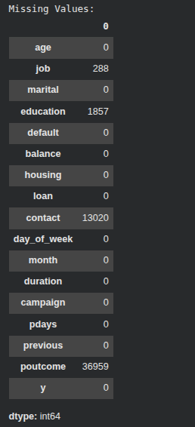
Figure 3: Missing Values Count per Feature
The first missing-value analysis displays the incomplete attributes on four features with very large gaps in contact and poutcome. This procedure promotes informed preprocessing choices, such that the correct imputation approaches are used and that biased model educating because of missing data not addressed occurs.
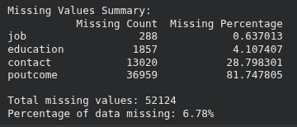
Figure 4: Missing Values Summary with Percentages
The summary variables the counts and percentages of missing values; poutcome has a severity of sparsity and contact and education have middle of the way gaps. This numerical understanding informs choice of imputation methods that do not distort data integrity as well as ensure the same feature distributions to be applied prior to the modelling.
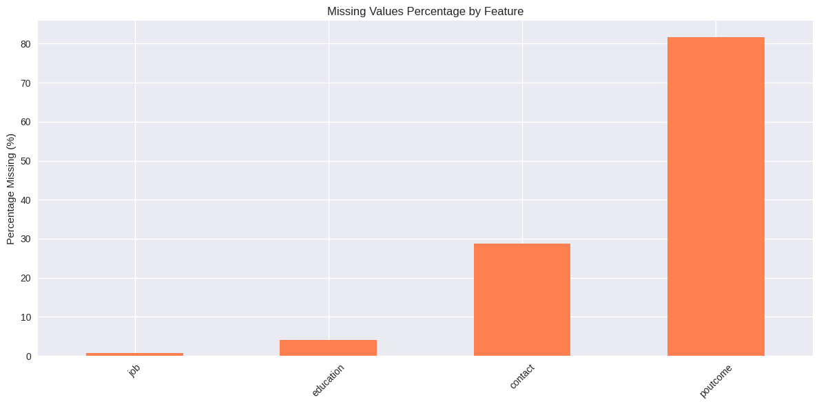
Figure 5: Missing Percentage by Feature
The bar chart plots missing-value proportions, and it is obviously evident that poutcome has extreme absence, and the contact has significant missingness. The graphical representation helps in prioritising the preprocessing activities and hardens the data justification of treating them with specialised imputation strategies.
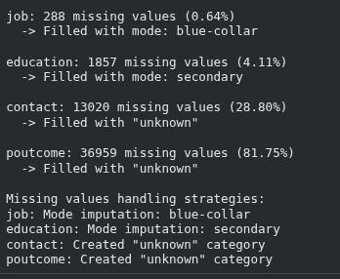
Figure 6: Summary of Applied Imputation Techniques
The mode is used to fill in missing values that may occur with low-missing features and the unknown category creates the unknown category to fill heavily sparse attributes. It is a hybrid strategy that ensures all data sizes remain, and categorical integrity is not lost, as well as promotes equitable training of models without any unrealistic flow of assumptions.
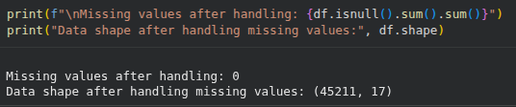
Figure 7: Missing Value Check After Imputation
Recent check of the dataset confirms the absence of any missing data values left and no change in the dimensionality, which proves the efficiency of the imputation strategy used. This provides clean fully usable data such that downstream algorithms did not get disrupted by null entries or inconsistent records.
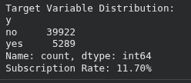
Figure 8: Distribution of Target Variable ‘y’
There is a strong imbalance in the distribution of the classes in the target distribution, where only 11.7% positive responses were collected. Such imbalance requires resampling or adjustments in the threshold to avoid biased learning and to make sure that the models learn minority-class behaviour that can be helpful in making meaningful predictions using most marketing.
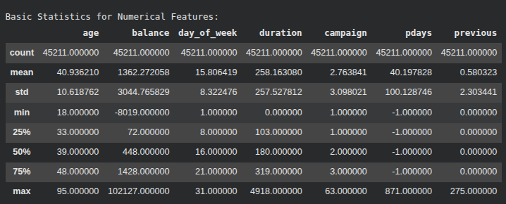
Figure 9: Summary Statistics for Numerical Features
The median and skewed distribution of durations show the presence of skewed balances and varying lengths of duration, which are summarized through descriptive statistics. These measurements ease scaling choices, spot abnormalities, and give background insight of data behaviour prior to implementation of machine learning formats.

VI. Result
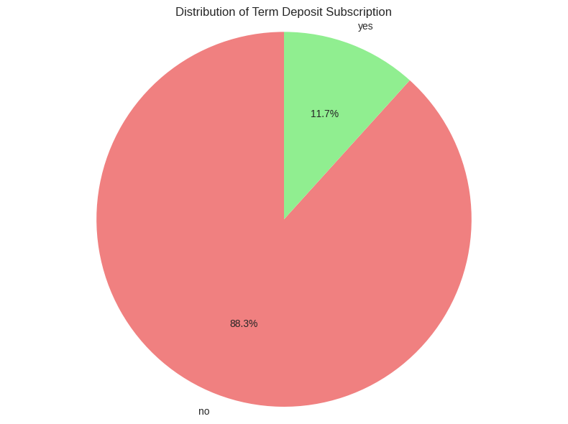
Figure 10: Distribution of Term Deposit Subscription
The pie chart is extremely unbalanced in terms of classes as only 11.7% subscribe. Returning to the imbalance, biases between the majority non-subscriber group and resampling shows that biases would be observed in the resampled models.
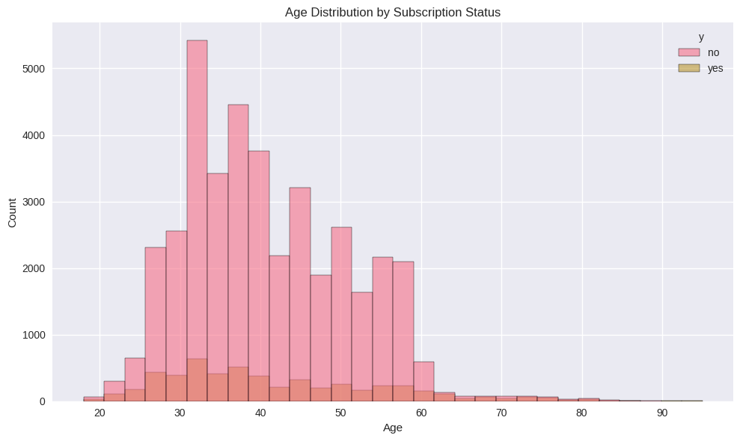
Figure 11: Age Distribution by Subscription Status
The age range of the subscribers is highly concentrated, getting 30-45 which forces the conclusion of stronger engagement of middle-career people. The non-subscribers dominate all the age ranges and this makes subscription rare and hard to detect minority patterns.
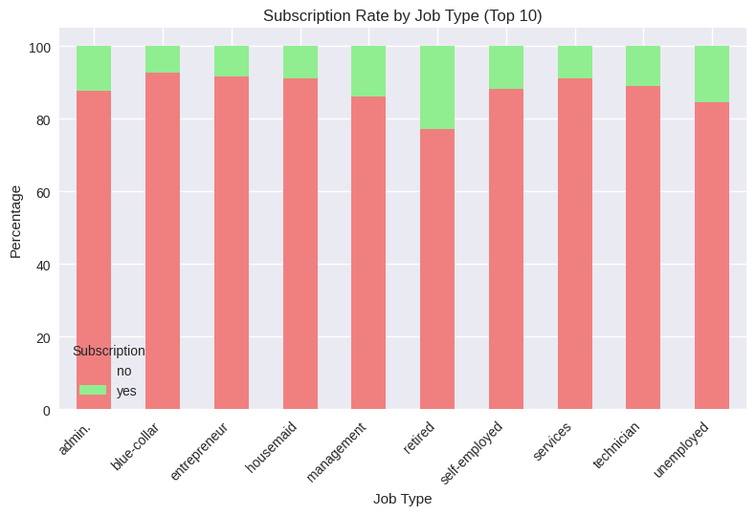
Figure 12: Subscription Rate by Job Type
The subscription rates of retired persons are very high in comparison with other occupations. The blue-collar and technician jobs have the least levels of interest, and this means that there are considerable occupation-based behavioural disparities that affect the success of campaigns.
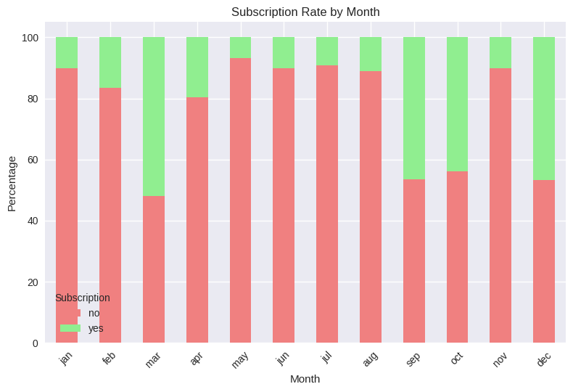
Figure 13: Subscription Rate by Month
March, September and December are significantly higher in terms of subscription rates implying that consumer choices show some seasonal trends. The timing of the campaign seems to be very important and months of the year have proven to be less effective.
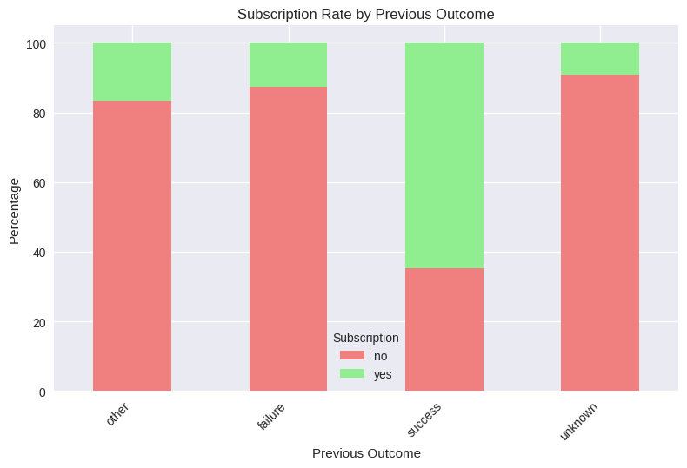
Figure 14: Subscription Rate by Previous Outcome
Customers who have recorded some success history display a high tendency to subscribe. At the expense of historical outcome, a strong predictor of behaviour, Unknown is statistically dominant although it is predominantly negative.
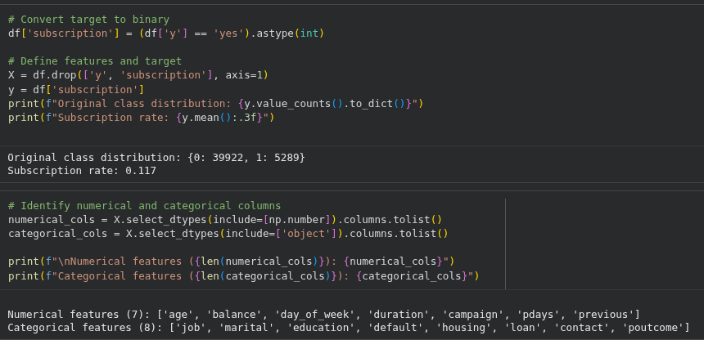
Figure 15: Feature Categorisation and Target Encoding
Binary encoding attests to incessant imbalance of classes, and feature separation validates seven numeric and eight categorical predictors that are used to inform relevant preprocessing, encoding, and model design.
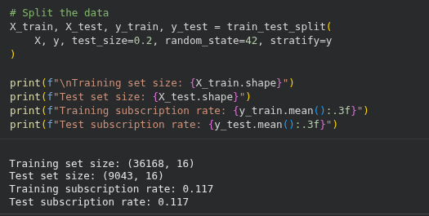
Figure 16: Train–Test Split Statistics
Stratified splitting preserves the same rates of subscription within sets so that there should be equal evaluation and no misleading model performance due to uneven representation of classes.
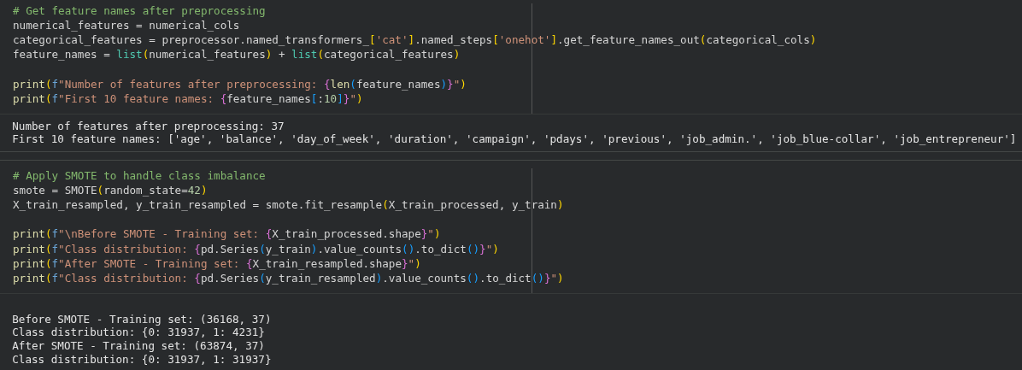
Figure 17: SMOTE Resampling Effect
SMOTE achieves a balance in the classes, balancing the population of minorities to that of the majority. This will guarantee a fairer training of models and a better sensitivity to unusual subscriber patterns.
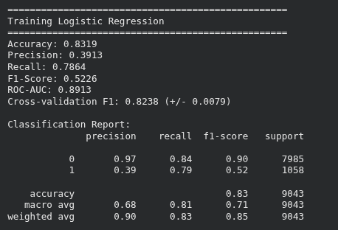
Figure 18: Logistic Regression Performance
Logistic Regression has good recall and poor precision on the minority class, which means it is good at detecting subscribers effectively, but falsely detected many cases in the minority, which makes it hard to have models to capture complex nonlinear marketing behaviours.
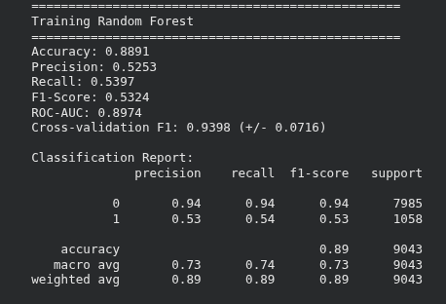
Figure 19: Random Forest Performance
Random Forest would increase the accuracy and the recall of subscriber forecasting, and it will offer a greater overall balance of measures. The higher ROC-AUC indicates that it has a greater capacity to discriminate than the Logistic Regression.
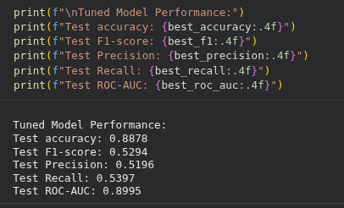
Figure 20: Tuned Random Forest Performance
Hyperparameter tuning provides slight gains in recall and AUC but low F1 gains, indicating the model already has default settings that are close to the optimal.
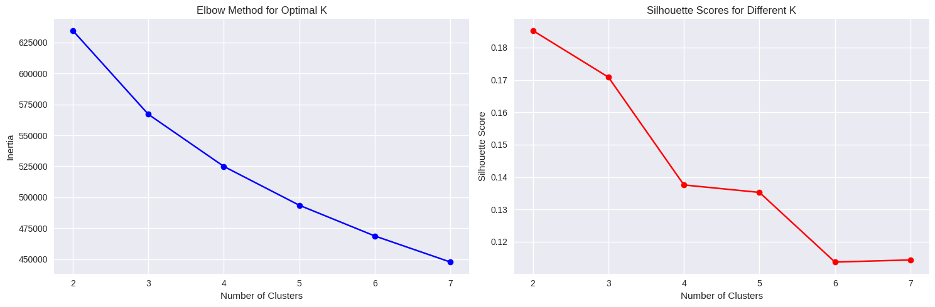
Figure 21: Elbow and Silhouette Analysis
Elbow and silhouette plots show that the returns feature diminishing returns after three clusters which implies that there is not much natural separability, which supports the idea that customer behaviour is complex in nature and loosely clustered.
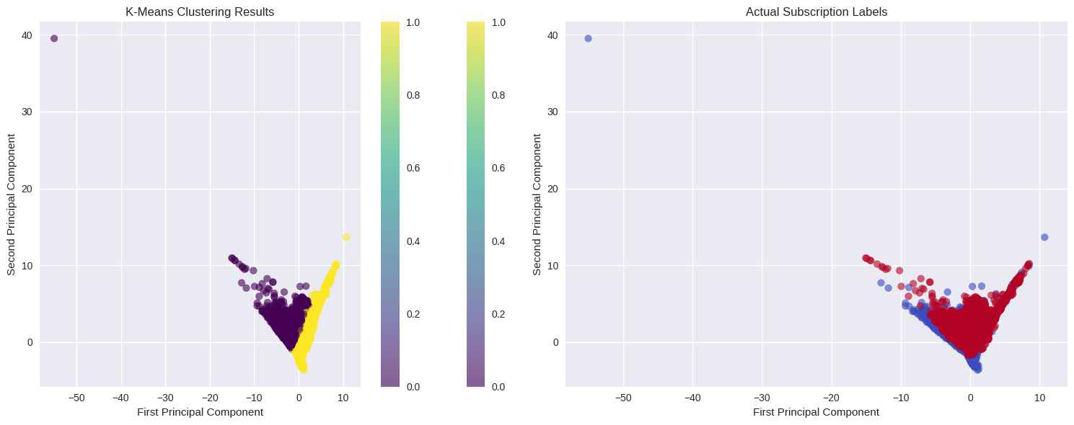
Figure 22: PCA Clustering vs Actual Labels
K-means grouping can only partially match real subscription markers meaning that it can just grasp behavioural trends without exhaustively recovering specific marketing results.
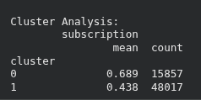
Figure 23: Cluster Subscription Statistics
Cluster 0 exhibits increased probability of subscriptions demonstrating a narrowing down of responsiveness customers. The lower rate of Cluster 1 is indicative of a wider and less involved demographic coverage.
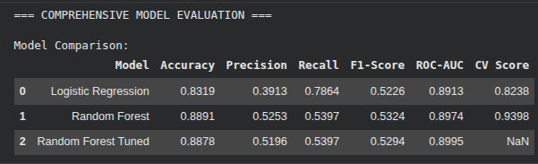
Figure 24: Model Comparison Table
Random Forest is obviously stronger than Logistic Regression on all measures, and tuning shows insignificant enhancement, which validates the stability of the model and great setup of the baseline.
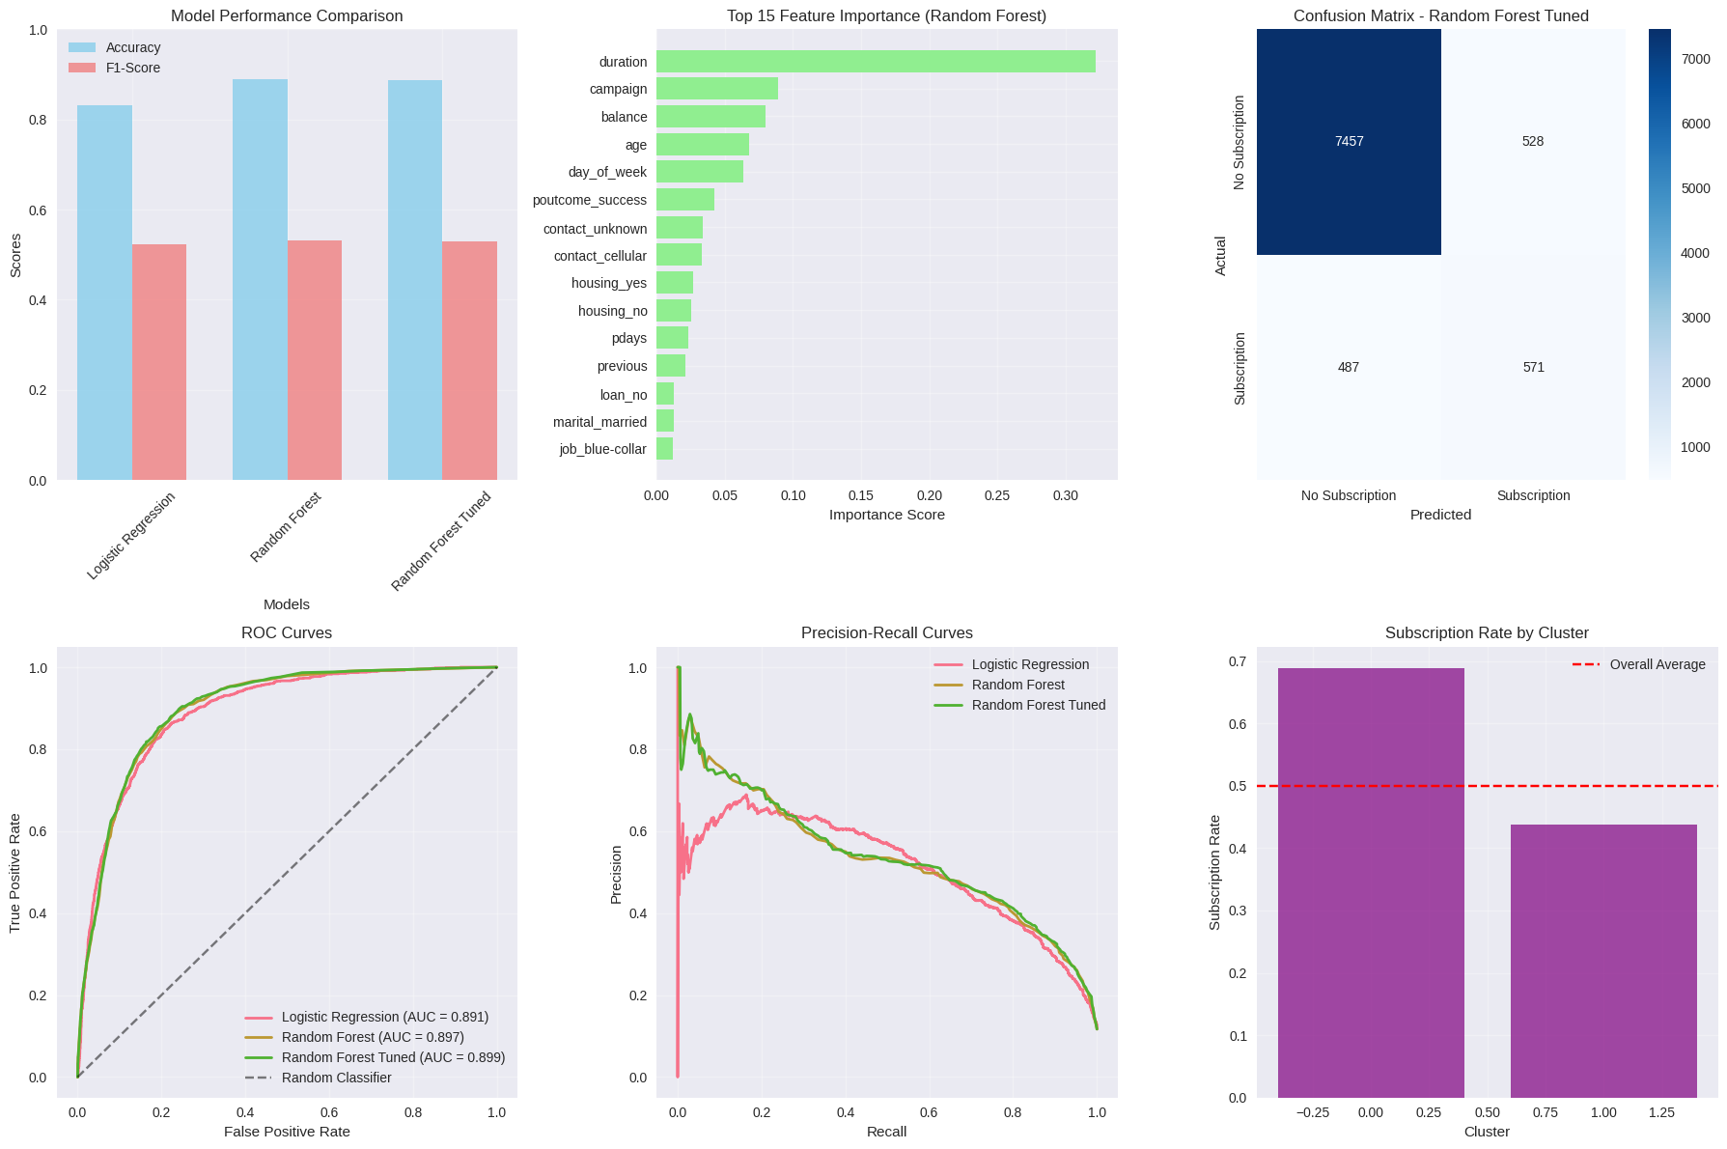
Figure 25: Performance and Feature Insights
Random Forest is the most precise and F1; duration is the most predictive. Scatter plot demonstrates good subscriber identification. ROC and PR curves substantiate constant high superiority all over decision thresholds.

VII. Discussions and Conclusion
The outcome of the experiment demonstrates definite differences in the performance of the considered models. Logistic Regression is good when it comes to recalling subscribers but is poor in terms of accuracy, which portrays its inabilities of capturing nonlinear patterns within the marketing data [4]. Random Forest achieves far better precision, recall, and F1-score which validates the capability to reflect intricate interaction between demographic and financial characteristics and campaign-related characteristics. Hyperparameter tuning can have a small improvement and this means that the baseline setup is already very close to optimal [5]. Roc and Precision-Recall curves display a consistent result referring to the fact that Random Forest is superior to Logistic Regression regarding the threshold settings.
The natural separability in the customer behaviour is minimal, as shown by clustering analysis. The K-means model finds a single cluster that is more responsive, but the consistency with the real labels is low, supporting the arguments that the role of subscription decisions need not be a single basis of fine-grained feature interactions, which are better discovered with the use of supervised optimization [10]. Ranking feature importance shows that duration, the number of campaigns, and financial aspects are essential factors in determining subscription, which confirms the prior knowledge in the domain.
Altogether, the best choice of a model is Random Forest, which provides comparable performance levels and generalisation. It is shown in the study that strong preprocessing, balancing classes, and feature engineering are important in improving the quality of prediction [1]. These results support the importance of machine learning in specific marketing and converting customers.

References
[1] Rogić, S., Kašćelan, L. and Pejić Bach, M., 2022. Customer response model in direct marketing: solving the problem of unbalanced dataset with a balanced support vector machine. Journal of Theoretical and Applied Electronic Commerce Research, 17(3), pp.1003-1018. https://www.mdpi.com/0718-1876/17/3/51
[2] El-Hajj, M. and Pavlova, M., 2024. Predictive modeling of customer response to marketing campaigns. Electronics, 13(19), p.3953. https://www.mdpi.com/2079-9292/13/19/3953
[3] Zaki, A.M., Khodadadi, N., Hong Lim, W. and Towfek, S.K., 2024. Predictive Analytics and Machine Learning in Direct Marketing for Anticipating Bank Term Deposit Subscriptions. American Journal of Business & Operations Research, 11(1). https://www.researchgate.net/profile/Ahmed-Mohamed-Zaki/publication/376585755_Predictive_Analytics_and_Machine_Learning_in_Direct_Marketing_for_Anticipating_Bank_Term_Deposit_Subscriptions/links/658a883d0bb2c7472b105cae/Predictive-Analytics-and-Machine-Learning-in-Direct-Marketing-for-Anticipating-Bank-Term-Deposit-Subscriptions.pdf
[4] Choi, Y. and Choi, J.W., 2023. Assessing the predictive performance of machine learning in direct marketing response. International Journal of E-Business Research (IJEBR), 19(1), pp.1-12. https://www.igi-global.com/viewtitle.aspx?titleid=321458
[5] Adekunle, B.I., Chukwuma-Eke, E.C., Balogun, E.D. and Ogunsola, K.O., 2023. Improving customer retention through machine learning: A predictive approach to churn prevention and engagement strategies. International Journal of Scientific Research in Computer Science, Engineering and Information Technology, 9(4), pp.507-523. https://www.researchgate.net/profile/Emmanuel-Balogun-11/publication/390113580_Improving_Customer_Retention_Through_Machine_Learning_A_Predictive_Approach_to_Churn_Prevention_and_Engagement_Strategies/links/67e1e22535f7044c9284e7d8/Improving-Customer-Retention-Through-Machine-Learning-A-Predictive-Approach-to-Churn-Prevention-and-Engagement-Strategies.pdf
[6] Kasem, M.S., Hamada, M. and Taj-Eddin, I., 2024. Customer profiling, segmentation, and sales prediction using AI in direct marketing. Neural Computing and Applications, 36(9), pp.4995-5005. https://link.springer.com/content/pdf/10.1007/s00521-023-09339-6.pdf
[7] Segun-Falade, O.D., Osundare, O.S., Kedi, W.E., Okeleke, P.A., Ijomah, T.I. and Abdul-Azeez, O.Y., 2024. Utilizing machine learning algorithms to enhance predictive analytics in customer behavior studies. International Journal of Scholarly Research in Engineering and Technology, 4(1), pp.001-018.https://www.researchgate.net/profile/Tochukwu-Ijomah-2/publication/383847908_5_Independent_Researcher_Australia_6_Independent_Researcher_USA/links/66dc4d542390e50b2c7214c1/5-Independent-Researcher-Australia-6-Independent-Researcher-USA.pdf
[8] Kedi, W.E., Ejimuda, C., Idemudia, C. and Ijomah, T.I., 2024. Machine learning software for optimizing SME social media marketing campaigns. Computer Science & IT Research Journal, 5(7), pp.1634-1647. https://www.researchgate.net/profile/Tochukwu-Ijomah-2/publication/383847411_Machine_learning_software_for_optimizing_SME_social_media_marketing_campaigns/links/66dc48492390e50b2c7213a8/Machine-learning-software-for-optimizing-SME-social-media-marketing-campaigns.pdf
[9] Ullal, M.S., Hawaldar, I.T., Soni, R. and Nadeem, M., 2021. The role of machine learning in digital marketing. Sage Open, 11(4), p.21582440211050394. https://journals.sagepub.com/doi/pdf/10.1177/21582440211050394
[10] Iyelolu, T.V., Agu, E.E., Idemudia, C. and Ijomah, T.I., 2024. Leveraging artificial intelligence for personalized marketing campaigns to improve conversion rates. International Journal of Engineering Research and Development, 20(8), pp.253-270. https://www.researchgate.net/profile/Tochukwu-Ijomah-2/publication/383847844_Leveraging_Artificial_Intelligence_for_Personalized_Marketing_Campaigns_to_Improve_Conversion_Rates/links/66dc47f92390e50b2c72139b/Leveraging-Artificial-Intelligence-for-Personalized-Marketing-Campaigns-to-Improve-Conversion-Rates.pdf
[11] Agboola, O.A., Ogeawuchi, J.C., Abayomi, A.A., Onifade, A.Y., George, O.O. and Dosumu, R.E., 2022. Advances in lead generation and marketing efficiency through predictive campaign analytics. International Journal of Multidisciplinary Research and Growth Evaluation, 3(1), pp.1143-1154. https://www.researchgate.net/profile/Jeffrey-Ogeawuchi/publication/391958983_Advances_in_Lead_Generation_and_Marketing_Efficiency_through_Predictive_Campaign_Analytics/links/684dcdfd11be4823fbde56a5/Advances-in-Lead-Generation-and-Marketing-Efficiency-through-Predictive-Campaign-Analytics.pdf

